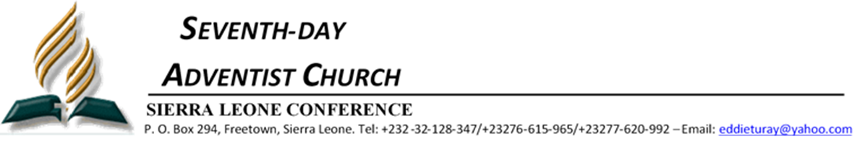

**FROM:** The Executive Secretary – Sierra Leone Conference (SLC)

**TO:** All Churches

**SUBJECT:** Pastoral and Departmental re-assignment

**DATE:** 6th March, 2025

Dear Brethren,

To meet with the present Pastoral and Departmental needs of the field, the Conference Administration had made the following Pastoral and Departmental re-assignment effective 1st April, 2025.

1. Pastor Abdulia A. Sankoh- Director for Stewardship, Publishing, and Church Pastor for Fountain of Love Seventh-day Adventist Church Wellington.
2. Pastor Aaron Gyinde-District Pastor Freetown-East district
3. Pastor Henry S. Bull- Director for Communication/PARL, Sabbath School/Personal Ministries and church Pastor for Good News Seventh-day Adventist Church, Congo Cross
4. Pastor Andrew Kawa- Director for Global Mission/Evangelism, Adventist Muslin Relation and Church Pastor for New Jerusalem Seventh-day Adventist Church, Lord Street, Waterloo.
5. Pastor Joshua J, Sesay-District Pastor Kunike District
6. Pastor John Koroma-District Pastor Yele/Petiful Mayeapoh District
7. Pastor Andrew J. P. Carew-District Pastor Masanga District
8. Pastor Shadrach M. Dumbuya-District Pastor Kono East/Kono West District
9. Pastor Maurice Edouard Bonnet-District Pastor Peninsula District.

Pastors not included in this list still maintain their present assignment. All Pastors are required to prepare a handing note.

Please members, give them all the support they need to perform their assigned duties and pray for them.

May God richly bless you for your cooperation.

Yours sincerely

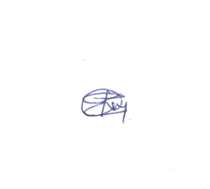

Pastor Edward K. Turay

**Cc:** President – SLC

“ “ Treasurer – SLC

“ “ File