**SIERRA LEONE CONFERENCE OF SEVENTH-DAY ADVENTISTS HEADQUARTERS**

**24, SAVAGE STREET, BROOKFIELDS FREETOWN**

**EDUCATION REPORT NOVEMBER 2024**

THE STATUS OF ADVENTIST EDUCATION IN SIERRA LEONE:

Adventist Education in Sierra Leone started as far back as 1950. To date it has one hundred and forty educational institutions to its name.

Table 1: Categories of schools in each region

|  |  |  |  |  |
| --- | --- | --- | --- | --- |
| **CATEGORY** | **WEST** | **NORTH-EAST** | **SOUTH -EAST** | **TOTAL** |
| **NURSERY** | 6 | 14 | 2 | 22 |
| **PRIMARY** | 9 | 57 | 27 | 93 |
| **JUNIOR SECONDARY** | 4 | 7 | 4 | 15 |
| **SENIOR SECONDARY** | 3 | 5 | 1 | 9 |
| **TERTIARY EDUCATION** | 1 |  |  | 1 |
| **TOTAL** | 23 | 83 | 34 | 140 |

Our Schools are currently working on meeting Denominational Accreditation Requirements. It is expected that Milton Comprehensive, Yele and Peninsular Secondary Schools that were once in the Year Book of the General Conference of the Seventh-day Adventists will reclaim their positions as these are the oldest of the lot.

As at now there is no Seventh-day Adventist Accredited School in Sierra Leone. The Church is simply the proprietor of School Properties and most of these properties do not have- Legal Title Deeds.

Frantic effort is been made to regularize our Church (Private) Schools. The claiming and upgrading of our Government Assisted schools are on-going.

Both efforts demand:

* The CHURCH in Sierra Leone takes full responsibility of the schools by investing in Adventist Education.
* The CHURCH integrates the Adventist faith into the learning system by training and equipping the teachers, Chaplaincy ,Guidance Counselling Units and School Clubs.
* The provision of Spiritual Materials for Schools.
* Effective Monitoring and Supervision
* The Church must strive to right all the wrongs in her Education System.

**ACCOMPLISHMENTS:**

**SCHOOL TOUR 2023/24:** At the beginning of the year a school tour was conducted by the Conference Education Director for the Western and South-eastern Region while that of the North-east was done by the Associate Education Director to share and also retrieve data on: Adventist Teachers, Trained and qualified teacher, staff size, class roll, annual activity plan which include Spiritual Activities, School Clubs, School Yearly Reports etc.

**PRE- CONGRESS SESSIONS**: The Pre-Congress sessions are preludes to the first grand Quinquennial SLC/SDA Education Congress which will be held in July/ August 2027

This year’s Pre-congress session 2 was a real challenge. The session (West) was held on 24th-26th July 2024 at the ZOE CARSS SDA Pre- School, Waterloo. Kenema District-21st-24th August was held at the Blessed Hope Seventh-day Adventist Church, Kissi Town, Kenema and that for the North was held at the Berea Church Agriculture Road, Makeni.

God in His graciousness made it possible for the session to be held for four days in each region. School authorities financed their feeding lodging and stationary. In each, a review of last year’s was done to evaluate progress made. Special emphasis in this year’s was on the WAD Accreditation Self Study Document, Annual Creation Sabbath and the Week of School Revival preceding it, Annual Education Session in August. the Quinquennial National Education Congress, Special Education Days in the Annual Calendar of Events, SDA Teacher Certification Programme, the MBSSE Teacher Licensing Exams, School Property Deeds and School Insurance .

**CREATION SABBATH 2024**

In collaboration with the Geoscience Research Institute, Creation Sabbath 2024 was celebrated in all schools and churches within the Conference to mark the fifteenth (15) Annual Celebration of the event. It marks the Conference ‘second celebration of Creation Sabbath. The week preceding Creation Sabbath was used as a Week of Revival for Schools- Nursery to Senior Secondary School. Sermons use for the 5 days Revival were taken from creationsabbath.net and that for Sabbath was for all our schools and churches.

Monday - How It All Began - Thomas Grove

Tuesday - Nature In The Light Of the Cross- Zdravko Stefanovic & L. James Gibson

Wednesday - Jesus and the Sabbath - Gory R. Council

Thursday – An Advance on Eternity- Robert Coster

Friday - The Rest of the Story- Robert Coster

Saturday- Rest in a World of Restlessness

The song, “Temple Made of Time” by Mark Bond was chosen as the Anthem for the year’s celebration. It was sung throughout during the Schools’ Revival and on Sabbath in Schools and Churches.

**YOUTH/ CAMPUS CHURCHES**: It is a departmental initiative to begin Campus/Youth Churches in our Secondary Schools where newly baptized young people from the school will be properly mentored and discipled to become witnesses for Jesus Christ. However, while the 33 souls baptized from Heisler Secondary School will be nurtured and cared for by Christ the King SDA Church, those who responded to the Altar Calls in Bo are going through Bible Studies to be baptized later.

**SCHOOL CLUBS**

The Launching of the Berean Bible Club took place on Sabbath 30th November 2022 at the Seventh-Day Adventist Church Tankoro Chiefdom, Kono, after a days’ Vacation Bible School at the same Venue.

Activities of this session include: Health Talks on:

Discusions on

The programme was concluded with the Berean Bible Club Inaugural Service and Baptism of nine souls by Pastor Themba Ngcobo, an Adventist Frontier Missionary Representative.

The Adventist Youth Clubs, Peer Counseling, Health, Reading and Writing Clubs are gradually taking firm footing in our schools.

**JOHN NEVINS ANDREWS Programme:** Together with the World Church the Department in all churches and schools commemorated J. N. Andrews’ 150 years of Overseas Mission. The National Association of Adventist Students Sierra Leone (NAAS-SL) did a very good job and reports came only from areas where these young people were involved**.**

**CONFERENCE EDUCATION BOARD:** The idea has already been presented to the Conference Administration.

**STAFF DEVELOPMENT:** The Department has collaborated with Heads of Schools to ensure Unqualified Teachers enroll with Chadwick Adventist College for the Diploma in Education Course. To the glory of God, the College now has seven (7) of these as her first crop of students in the Education Department.

**SCHOOL DEVELOPMENT PROJECTS**

Samuel Town SDA Primary School:-

* Construction of a Three Classroom Block by Project 3580 from the UK
* The rehabilitation of A Six Classroom and a Store by Project 3580
* Donation of Solar Lights by Counsellor Osman Sesay of Cinstituency 108

Abigail Butscher SDA Primary School-

* Construction of a Secondary School by the Madieu Williams Foundation. The Project has made provision for twelve (12) classrooms, twelve (12) restrooms, five (5) office spaces, two (2) staffrooms, one (1) Library and one (1) Laboratory.

**CHADWICK ADVENTIST COLLEGE**(CAC)

Following a Peer Review Visit on 30th August 2023, Chadwick Adventist College, in May 2024, has finally gained Accreditation from the National Council for Technical Vocational and Other Academic Awards for the following Diploma Programmes:

1. Theology and Religion

2. Computer Science

3. Accounting and Finance

4. Banking and Finance

5. Business Administration and Management

6. Development Studies

7. Human Resource Management

8. Procurement and Logistics

9. Educational Administration

However CAC, in her first year was able to offer just three of these which were Theology, Computer Science and Accounting and Finance.

With a total of (17) students who took the final exams, Chadwick Adventist College by the special grace of God has gone through her maiden year.

**WAD Education Assessment Visit**. From April 28 to May 1, 2024, the West-Central Africa Division (WAD) Education Director, Ps. Juvenal Balisasa and WAUM leaders paid an Assessment Visit.

**IBE Assessment Visit: The** International Board of Education (IBE) Team led by Prof. Hudson Kibuuka also paid an Assessment visit on June 26th-29th to qualify the College for operational approval. We are pleased to announce that it has been voted at the Adventist Accreditation Association (AAA) to accept both the IBE and IBMTE recommendations to accept the assessment visits reports. May Gods name be exalted for ever.

**November Week of Prayer**: Distributed the Week of Prayer Materials to Schools and continued promotion to ensure maximum compliance.

**ADVENTIST JOURNAL OF EDUCATION**

In response to a request from the Union Education department, the following report was sent to the Adventist Journal of Education.

**EDUCATION DEPARTMENT’S REPORT ON SCHOOL REVIVAL 2023 AND CHADWICK ADVENTIST COLLEGE FOR**

**THE JOURNAL OF ADVENTIST EDUCATION**

The Revival was held in ten (10) Seventh-day Adventist Secondary Schools within the Conference. It was run from Monday October 23rd - Creation Sabbath October 28th. 2023.

**The theme was “END *TIME MESSAGES FROM JESUS TO THE WORLD*” , Theme Song SDAH 213 ( Jesus Is Coming Again ) and Daily Topics were:** Monday-World’s Last Empire**;** Tuesday- Formula for a Crime-free Society **;**Wednesday- If God is Good, Why so Many Sufferings ?;Thursday- Signs of His Coming; Friday-God’s Prescription for Happinessand Sabbath-God’s Seal of Survival.

Daily presentations were done by Pastors while each member of the School Community contributed to the success of the program.

We were blest with two hundred and seventy-four (274) souls. Two hundred and sixty-eight (268) were pupils, five (5) teachers and one (1) visitor form the school neighborhood. 296 were baptized on Creation Sabbath 2023 and 9 on a Women’s Ministries Retreat…….

**RETENTION STRATEGIES:**

* Campus / Youth Church with supporting Elders
* Provision of King James / New King James Bibles
* Mentoring Programme- Members volunteered to supervise and mentor the newly baptised.
* Discipleship Curriculum- (Baptismal Manual, Profile, We Believe)

Coordinated by : Education Director- Arieola L.F. Moiba

Ministerial Director- Ps. Pastor John F. Koroma; Campus Ministry Director- Nyuma K. Mustapha and Abass Pele Conteh- Conference Treasurer.

Pastor Mohamed Duada preaching and Pastor Bull baptizing students of Heisler SDA Secondary School Kissy Mess Mess

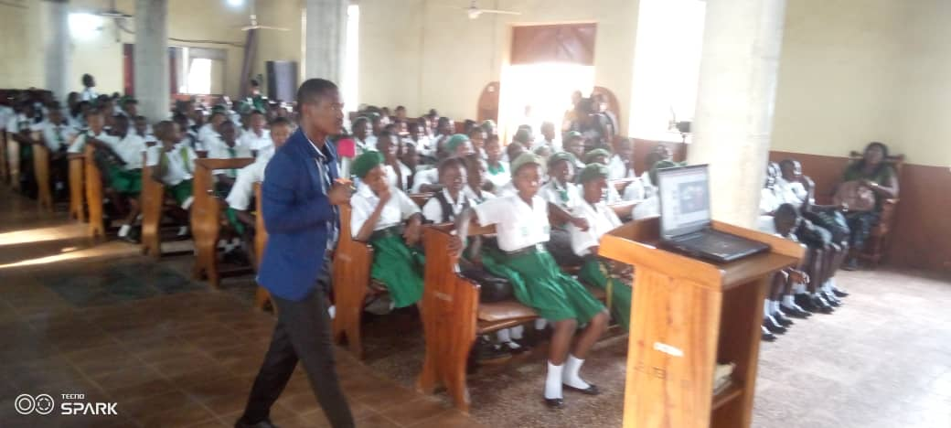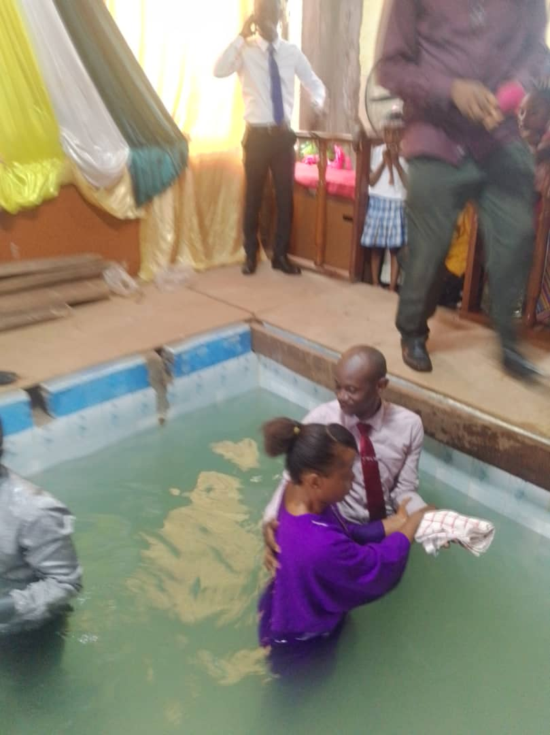

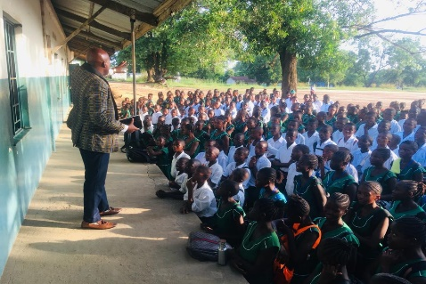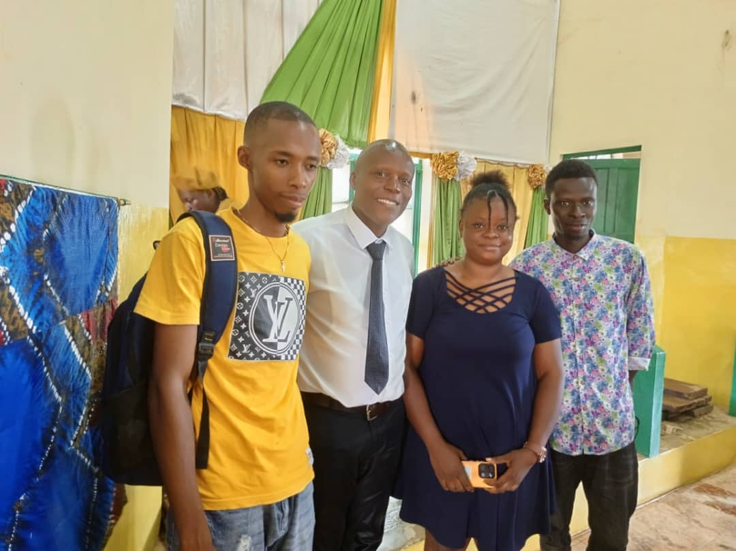

Pastor Andrew Kawa preaching Pastor Kawa and 3 of the teachers baptized

at Milton Comprehensive, Bo (One was a Muslim)

Chadwick Adventist College, founded in 2023, is Sierra Leone’s first Seventh-day Adventist Tertiary Institution, dedicated to promoting academic and spiritual growth. With a strong commitment to Adventist values, Chadwick Adventist College strives to deliver high-quality education and foster wholistic development. From April 28 to May 1, 2024, the West-Central Africa Division (WAD) Education Director, Ps. Juvenal Balisasa and WAUM leaders paid an Assessment Visit. Nationally, Chadwick has secured a Three Year Accreditation from the National Council for Technical, Vocational, and other Academic Awards (NCTVA), affirming its academic standards and legal status after a Peer Review Visit May 2, 2024. The International Board of Education (IBE) Team led by Prof. Hudson Kibuuka also paid an Assessment visit on June 26th-29th. to qualify the College for operational approval. We are pleased to announce that it has been voted at the Adventist Accreditation Association (AAA) to accept both the International Board of Education (IBE) and International Board of Ministerial and Theological Education (IBMTE) recommendations to accept the assessment visits reports. CAC invites continued support as we embark on this mission to nurture future leaders.

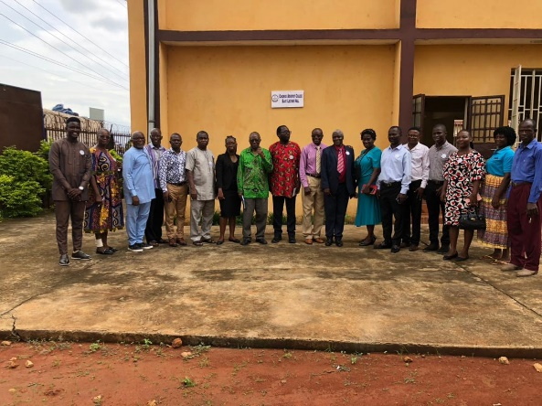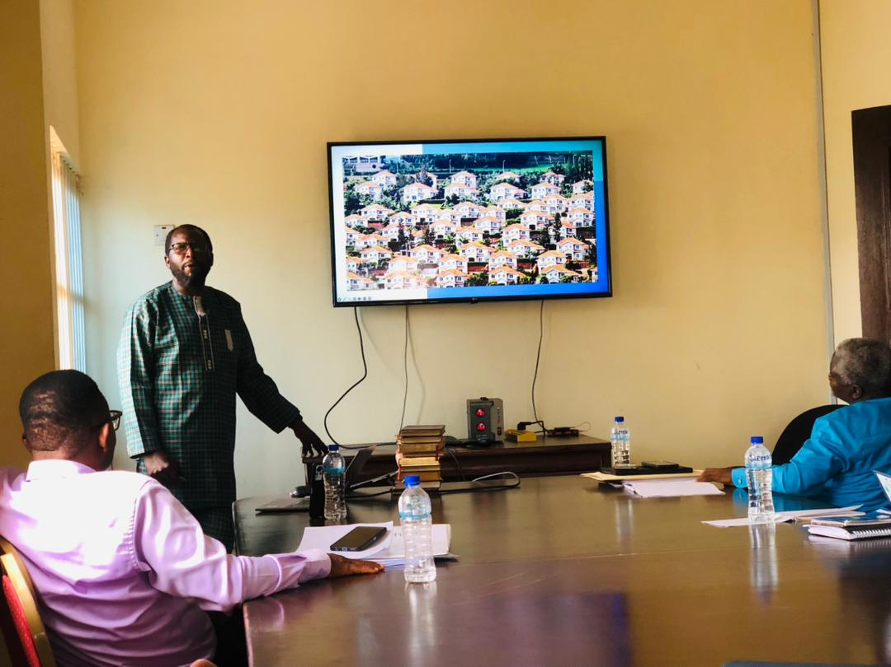

IBE/CAC Assessment visit with Prof. Hudson Kibuuka

WAD/CAC Assessment visit with Dr. Juvenal Balisasa

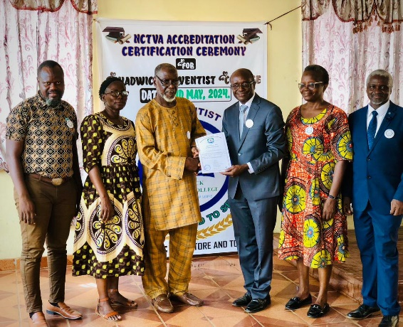

NCTVA Accreditation Certification program with- Prof. Abdulia Babatunde Karim

Compiled and submitted:

Arieola L.F. Moiba

Education Director SLC-SDA

And Mustapha Bayoh Public Relations and Marketing Officer CAC`

**ANNUAL BUDGET 2025**

**DEPARTMENTAL BUDGET 2025**

|  |  |  |  |  |
| --- | --- | --- | --- | --- |
| **DATE** | **ACTIVITIES** | **MATERIALS REQUIRED** | **PERSON RESPONSIBLE** | **BUDGETTED AMOUNT** |
| Jan- Dec | General Office Expense. | Stationeries, toiletries, | SLC | 500.00 |
| Jan | Office Operations. | 1.Desk-Top Computer and Printer  2.Dual Camera to enhance Effective Departmental Tours  3. Notice Board | SLC  SLC  SLC | 20,000.00 |
| Jan | Effective Internet Connection | Internet Connectivity | SLC |  |
| February 9-15th | Week of Education Emphasis in Church and Schools. | Paper and Ink | SLC | 500.00 |
| March 4-11 2025 | WAD Educating for Mission Conference-Soluso University, Bulawayo, Zimbabwe. | Flight and per diem | SLC | 40,000.00 |
| March 23rd. | Christian Education- Chadwick Adventist College Day to be celebrated in Churches and Schools. | Paper and Ink | Chadwick Adventist College | 500.00 |
| August 11th-16th.  August 16th | -Annual Education Session/Teacher Certification Programme  -Annual Teachers Consecration Service  -Education Sabbath in Schools and Church. | -Paper, Ink Transportation and Per Diem | -Teachers’ DIY Programme  SLC | 1000.00  500.00 |
| October 11TH.-15TH.  October 16th. | -Week of Revival in Schools  -Fruit Trees Planting in Church and School Communities  -Celebration of Creation Sabbath in Church and Schools. | Paper and Ink | SLC  SLC  SLC | 500.00 |
| TOTAL |  |  |  | 63,500.00 |

**EDUCATION DEPARMENT’S CALENDAR OF EVENTS 2025**

|  |  |  |
| --- | --- | --- |
| **DATE** | **ACTIVITIES** | **RESOURCES** |
| January 8-18 | Ten days of prayer- Churches and Schools | WAD/WAUM/SLC |
| February 9-15  24-28 | Week of Education Emphasis in Churches and Schools. (WAD Impact 2025 Pre- Campaign Revival)  Wad Impact 2025 My School for Jesus Campaign | WAD/WAUM/SLC |
| March 4-11 | WAD Educating for Mission Conference-Soluso University, Bulawayo, Zimbabwe. | WAD/ WAUM/SLC |
| March 23rd. | Christian Education Sabbath- Chadwick Adventist College Day- to be celebrated in Churches and Schools | CAC/SLC |
| August 11th-16th.  August 16th | -Annual Education Session / Teacher Certification Programme  -Annual Teachers’ Consecration Service  -Education Sabbath in Schools and Churches | SLC EDUCATION/WAUM/WAD  WAD/WAUM/SLC/ Education Department |
| October 11TH.-15TH.  October 16th. | -Week of Revival in Schools - from Early Childhood– Tertiary Level)  National Fruit Tree Planting in all Church and School Communities.  -Celebration of Creation Sabbath in Churches and Schools. | -SLC/ Education , Children’s Departments and Ministerial Council  -Geoscience Research Institute/SLC |

MAPUTO PROTOCOL: REPORT ON THE SIDE BY SIDE FAITH MOVEMENT FOR GENDER JUSTICE WORKSHOP

Workshop Theme : Empowering Women and Girls through the Implementation of the Maputo Protocol.

Workshop Dates : 26th and 27th.November 2024.

Venue : Council of Churches Sierra Leone (CCSL) Hall, King Harman Road, Freetown.

**GOAL:** To deepen understanding and foster actionable strategies concerning women and girls rights, particularly focusing on key provisions outlined in the Maputo Protocol. The workshop aimed to address three critical areas: harmful traditional practices, violence against women and girls, and economic empowerment.

**OBJECTIVES:**

1. To deepen participants’ understanding of the Maputo Protocol and its relevance in promoting the rights of women and girls across Africa.
2. To identify and analyze the barriers and challenges that hinder the advancement of women and girls in society.
3. To facilitate the development of actionable strategies and solutions to address the identified challenges.

After the Welcome Address, Statements were from the Chairman Side by Side Movement for Gender Justice and the Country Representative, Christian Aid, Sierra Leone.

Topics Presented were:

Day 1.

Introduction to the Maputo Protocol

Contextualizing HTPs

Dynamics of Gender Based Violence

Prevention and Response Mechanism

Legal Framework and Policies Response

Child protection with reference to section 35- Policy Intervention and Challenges

Day 2.

Economic Rights and Empowerment

Entrepreneurship and Livelihood Development

Strengthening Partnership and Collaboration

Policy Advocacy and Sustainable Development

Questions and Answers, Group Discussion and Presentation

The workshop was very educative and it is important that the Church educates and sensitizes her Congregation and Communities on the contents of the Maputo Protocol.

**CHALLENGES:**

* Getting report from the fields( School/ Church) is almost impossible
* Getting Church to invest in the Training of Teachers and the Establishment of SDA Schools.
* Very low Education Departmental Budget - even for office operations and internal travels
* The Church’s refusal to invest in Adventist Education had made operating Church Schools as Private Adventist Schools an herculean task.
* The School is in dire need of Trained School Chaplains and Guidance Counselors.
* The Role of Pastors as school Managers needs to be documented and made clear to avoid confrontations with school authorities.
* School lands are not adequately documented and therefore hinders development Projects.
* Getting the Local Church to elect Education Secretary to coordinate the affairs of Adventist Education at Local Church Level.

**FUTURE PLANS:**

* To visit, photograph and document every School that goes by the Sierra Leone Conference of Seventh-Day Adventists’ name and report to the Church.

* To ensure that every teacher in our schools is professionally trained and qualified.
* To create a well-structured TEACHER FUND in each Region to enhance financial base for Congress Sessions.
* To add Teacher Award Ceremony to the Annual Education Session’s Programme.
* To officially inform Government of the sixty percent Pass Mark Position of Seventh-Day Adventist Schools in Sierra Leone.
* To write and present a Position Paper Against Sabbath Classes and Examinations to government
* To continue to sensitize the church to accept and invest in Adventist Education
* New Converts in Youth/ Campus Churches are discipled, mentored and monitored with the right materials to ensure retention.
* To ensure that we redeem our Adventist Schools by faithfully complying to the Accreditation Requirements as are stated in the K-12 Self Study Accreditation Tool.
* To ensure every Seventh- day Adventist in the Teaching Profession goes through the SDA Teacher Certification Programme and State Teacher Licensing Examination
* Private Schools are managed as Seventh- Day Adventist Private Schools
* No new school is built without following due process.
* To strengthen the various School Chaplaincy and Guidance Counseling Units with Training and Equipment
* To promote and support Staff Development Programmes
* To ensure annual School Baptism Goals are met by promoting and supporting the integration of Faith and Learning.
* To sensitize and educate the school on State Constitutional matters –especially those on Human Rights.
* To ensure the school maintains a clean and safe environment for its community

Submitted by:

Arieola L. F. Moiba (Mrs.)

Education Director SLC SDA